**Project Setup Step:**

1. Install xamppserver and click on xamppserver icon and activate it.
2. paste '<http://localhost/phpmyadmin/>' in new tab then enter user 'username' and passward 'password'

[

$cfg['Servers'][$i]['user'] = 'root';

$cfg['Servers'][$i]['password'] = '';

]

1. create database in phpmyadmin named as 'erp' and import 'assignment.sql' file from project
2. now past this url '<http://localhost/ERP_System/index.php>' in tab for user vie

**Installation**

Minimum requirements: PHP 5.5.9 & PostgreSQL 8.4 or MySQL 5.6

## Documentation

Documentation: Quick Setup Guide, User Manuals, Report samples, Tips, Wiki.

## Screenshots

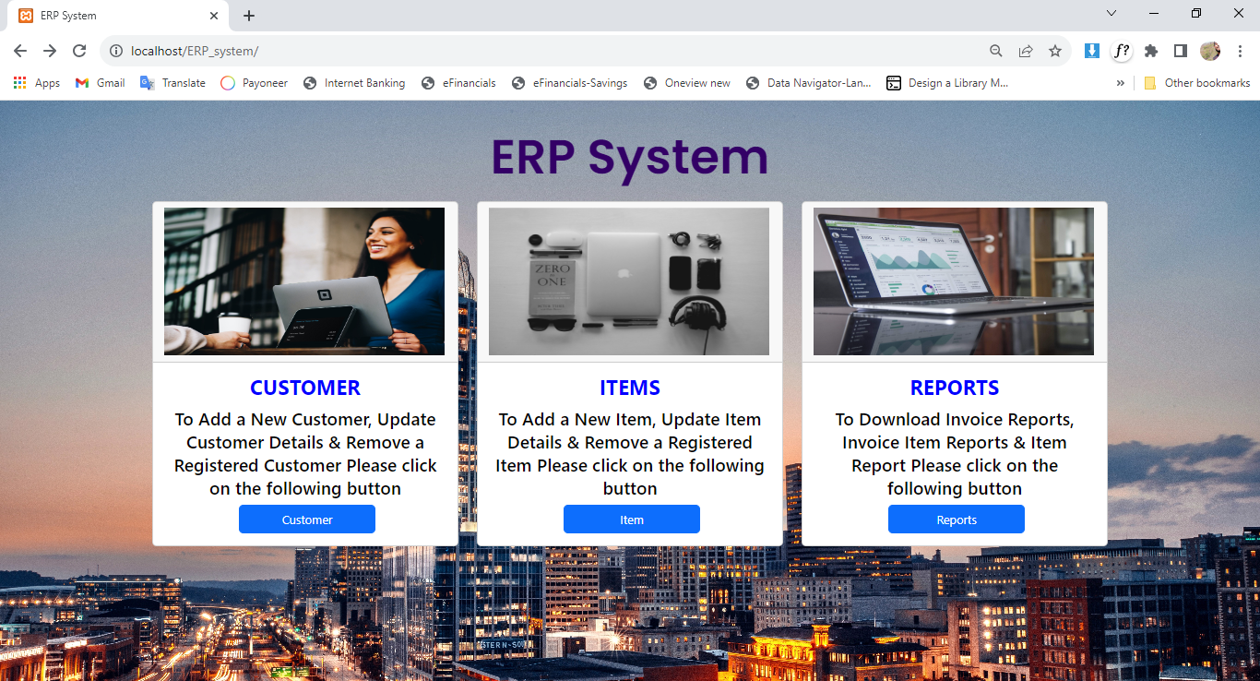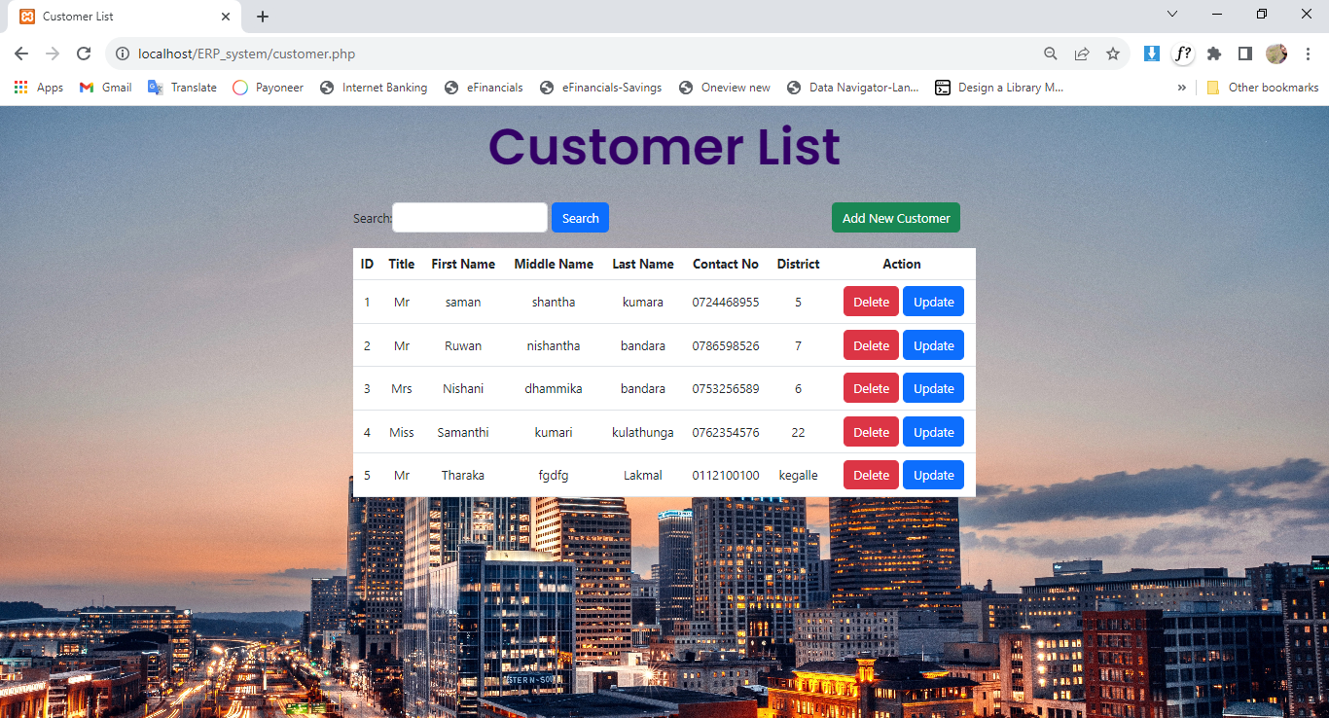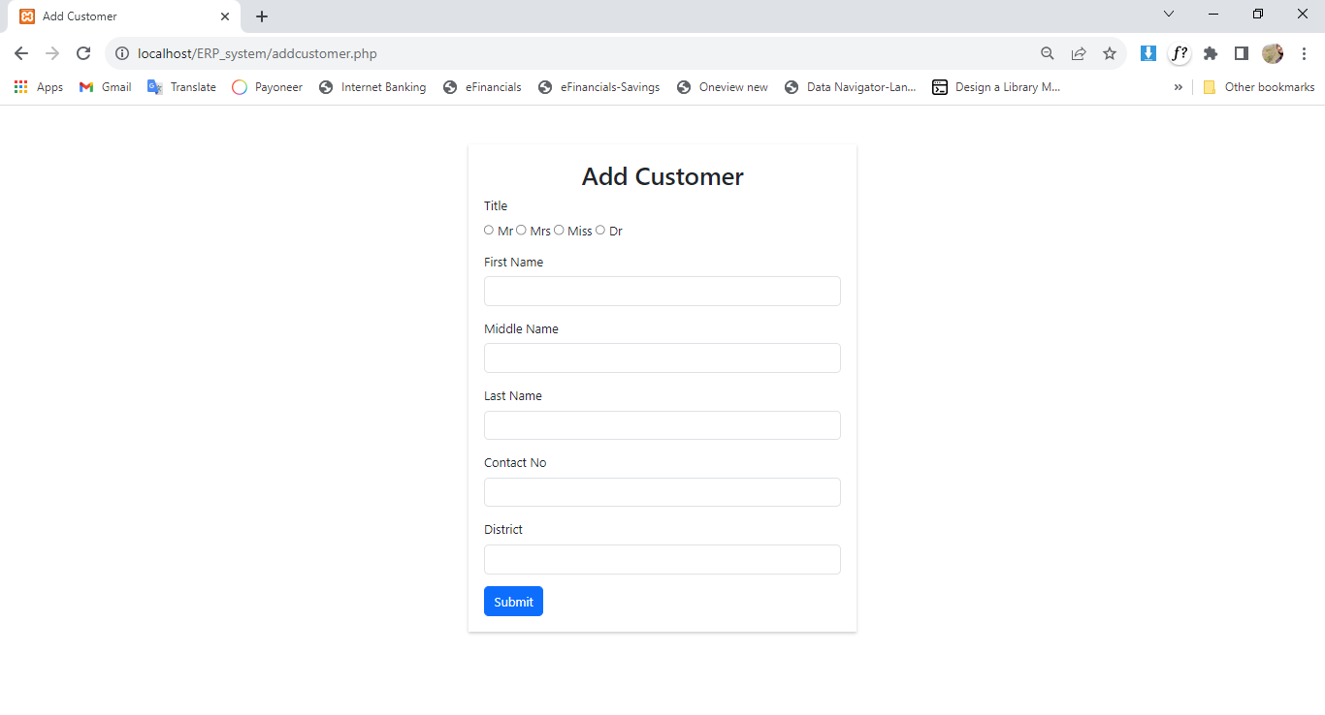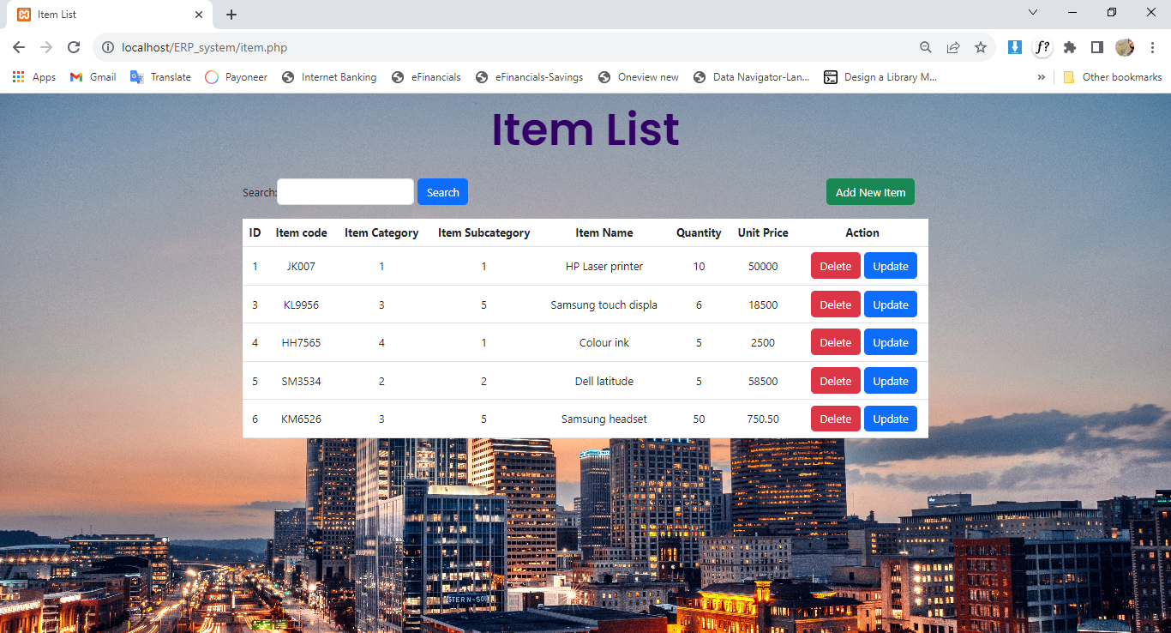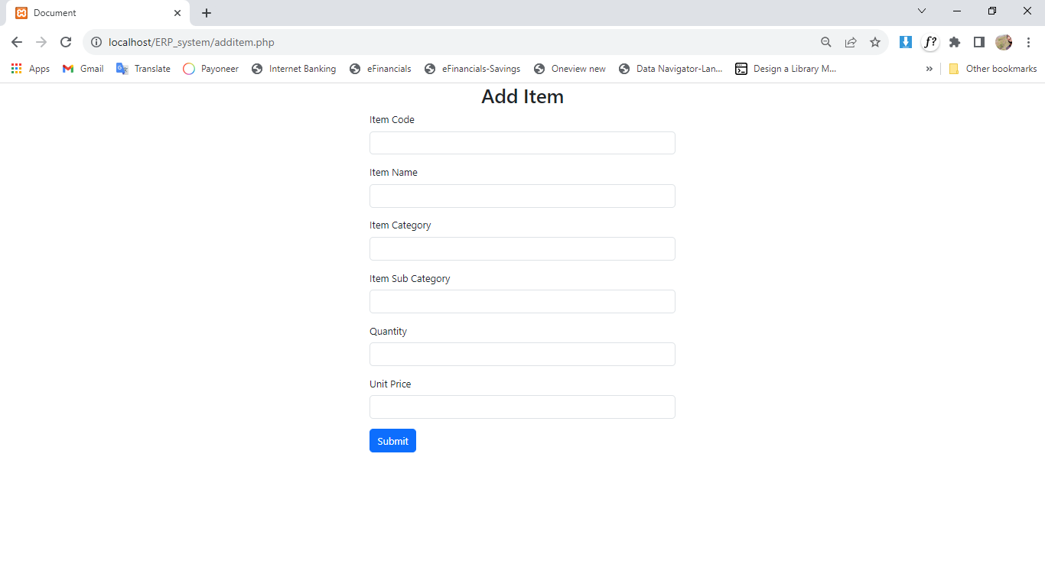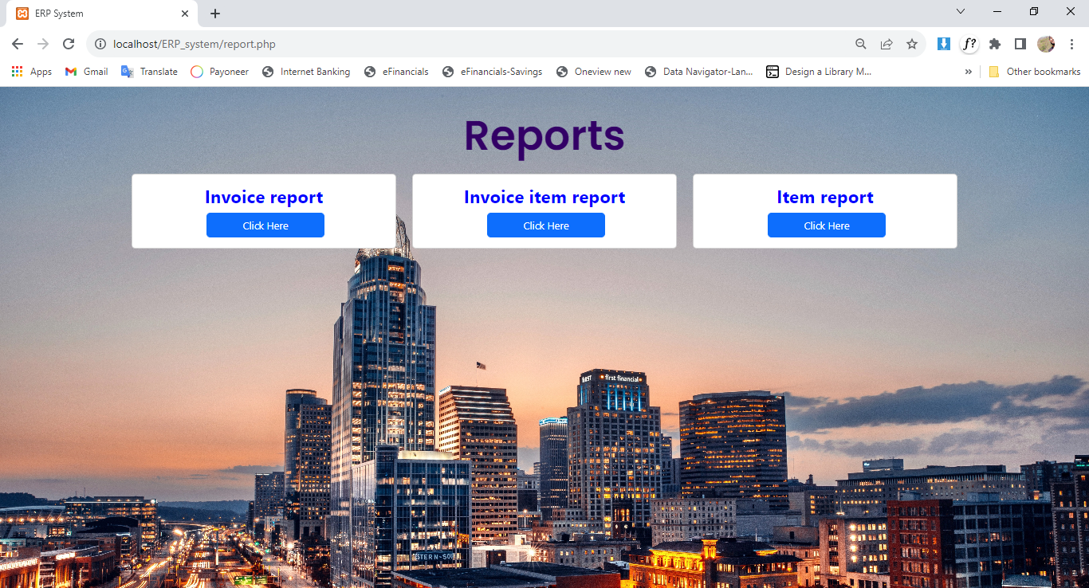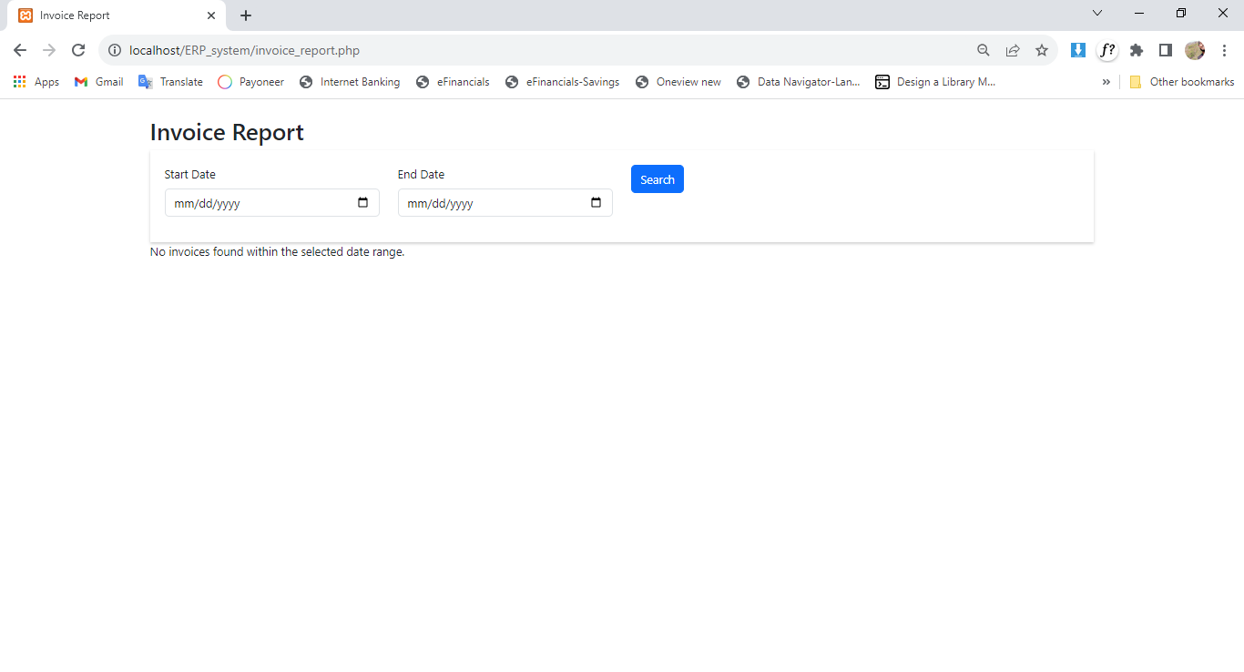

## About

From this ERP System you can

Add Items & Customers

Remove Items & Customers

Update Items & Customers

Check your reports (any Date rang)